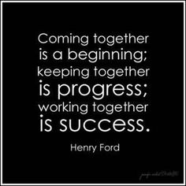

* * *

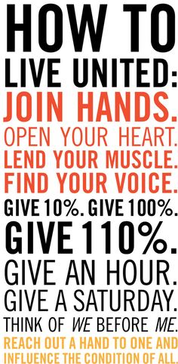

* * *

# 

2019/2020 Leadership Giving Circle

United Way of Haywood County

**BRONZE CIRCLE**

Thomas F. Armstrong

Benjamin Blakley

Wilma Scott Boatwright

John and Myra Bottoms

Derric and Donna Brown

Misti Carver

John and Jan Chicoine

Don and Denise Coleman

Douglas Conner

Randall Conner

Patsy Davis

Scott Dionne

Michelle Dobson

Richard and Susanne Edwards

Audrey Gaddis

John and Ann Geers

John Hawkins

William Heineman

Wendy Hines

Kenneth Jacobine

Rex LaRowe

Ron and Laura Leatherwood

George and Marleen Marshall

Wallace McDonald

Mike and Jane Mehaffey

Daniel Meyer

Bill and Malene Nolte

Elizabeth Parks

Scott Ray

Rodney and Brenda Smith

Ken and Carol Thomas

Laurin M. Traub

Ann Whaley

Michael Whitaker

Barry and Celesa Willett

Laura A. Willis

Kenneth and Deborah Wilson

Danielle Wittekind

Nicholas Woody

Bryan and Jeanann Yates

Anonymous Donors



|  |
| --- |
| **ALEXIS DE TOCQUEVILLE** |
| Chuck and Nancy Beemer  Bradford Stanback & |
| Shelli Lodge-Stanback |
| **PLATINUM CIRCLE** |
| Sam and Kathleen Bell  Tom and Patricia Butler  Craig and Laura Linger |
|  |
| **GOLD CIRCLE** |
| Lee Galloway & Nancy Thompson  Stephen and Annette Hutchins  Ross Irvine  Max and Susan Kimel  Tom and Sally Moore  Taylor Pope  Tom and Pat Posey  Buddy and Jane Young |
|  |
| **SILVER CIRCLE** |
| Ronald L. Allen  Everett I. Baucom  Ray and Jann Bellamy  Robin and Tom Batchelor  Ignacio Borges  John and Carolyn Bowers  Daniel and Betsy Boyd  Larry and Brenda Clark  Ronald P. Clauser  Robert DeLine  Nicole Etheridge  Rachel Fosser  Gordon and Dianne Goodgame  Max Geragosian  Doris Hammett  Kristen Hammett  John Highsmith and Sandra Hayes  David Jenkins  Alexander Jones  Carol Kashmer  Rolf Kaufman  Larry and Julie Leatherwood  David and Leah Mehaffey  Douglas Muir  Samantha Murphy  Maurice and Claire Phillips  Frank G. Queen  Matthew Scarborough  Todd Seymour  Ricky and Kathy Sheppard  Laryssa Smith |
| Scott R. Stevens  Denise Teague  Herb and Pat Van der Ven  Ethan Watts  Paul Wilson  Charles Umberger |
| Bill and Treva Upton |

. . .

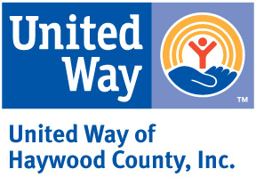

PO Box 1139

Waynesville, NC 28786

|  |  |  |
| --- | --- | --- |
|  | 2019/2020 Annual Report |  |

Nonprofit

US Postage Paid

Waynesville NC

28786

Permit #57

**The United Way goal was $335,000. In the 2019/2020 campaign, $268,197.61 was raised.**

MEMBER AGENCIES

Arc of Haywood County Maple Leaf Adult Respite

Big Brothers Big Sisters Mountain Mediation Services

Clothes to Kids Mountain Projects, Inc.

Daniel Boone Council -Safe at Home

HIGHTS. Inc. -Congregate Nutrition

LifeWorks -Foster Grandparent/-

Haywood County 4-H Senior Companions

Haywood Meals on Wheels -Haywood Volunteer Ctr

Reach out and Read Carolinas OnTrack Financial

Haywood Pathways Ctr Reach of Haywood County

K.A.R.E. The Community Kitchen

Manna Food Bank The Salvation Army

BOARD OF DIRECTORS

Chad McMahon – President

Holly Rogers – Vice President

Audrey Gaddis– Secretary

Denise Coleman – Treasurer

Paige Bridges

Lewis Clark

Wendy Hines

Tara Keilberg

Sharon Lanning

Jeremy Phillips

Jeff Schandevel

Fred Waring

Joey Webb

Danielle Wittekind